**EXP 15** Create a Cloning of a VM and Test it by loading the Previous Version/Cloned VM

**PROCEURE:**

**STEP 1** Install VM ware software

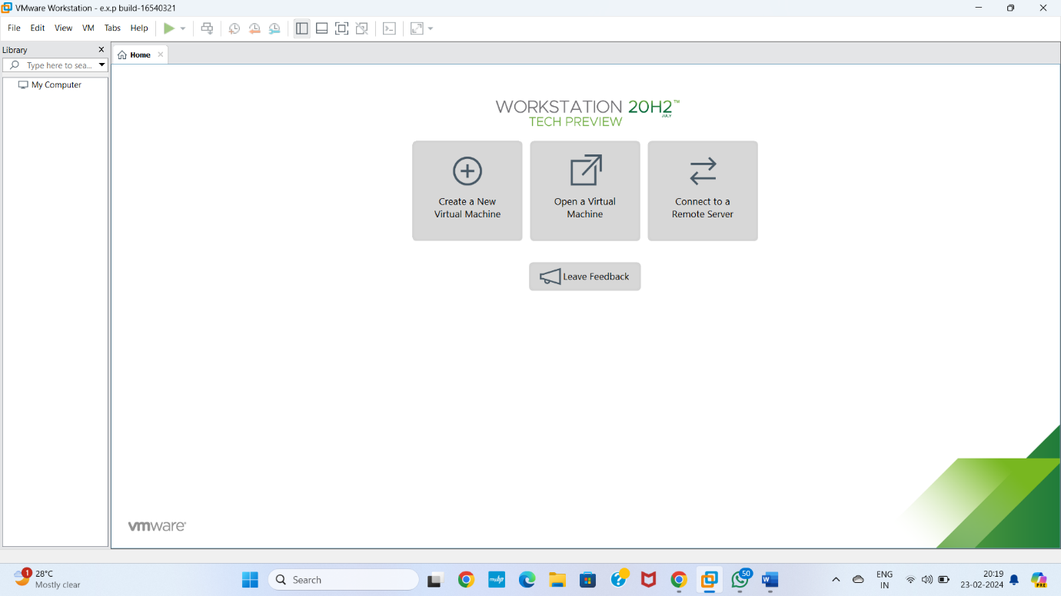

**STEP 2** CREAT A NEW VIRTUAL MACHINE GIVE NEXT

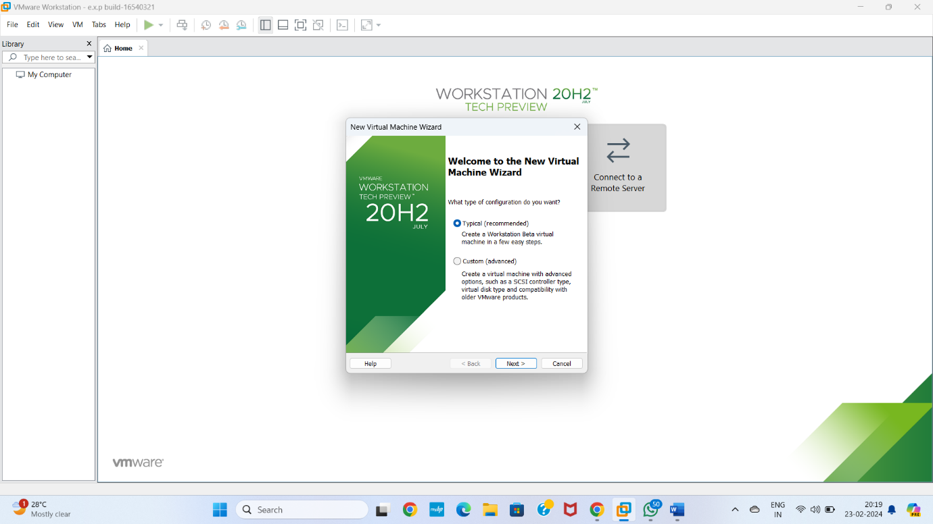

**STEP 3** Select I will install operating system later Give next

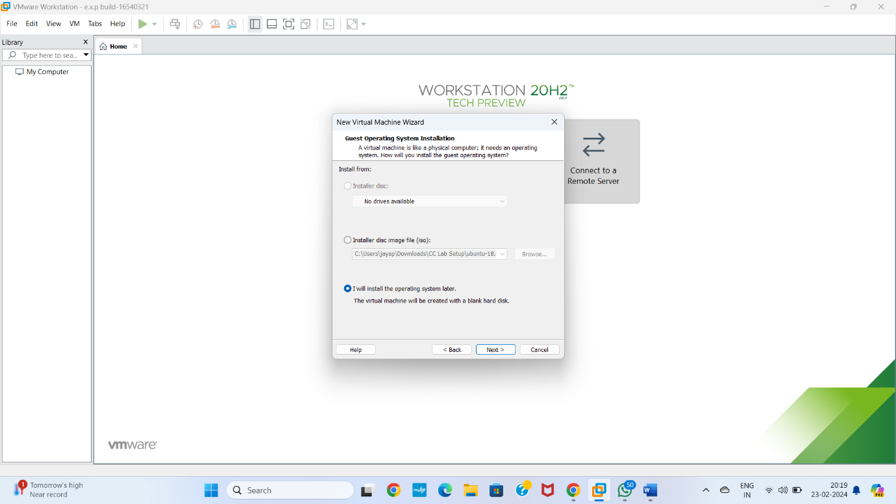

**STEP 4** Select gust operating system Give next

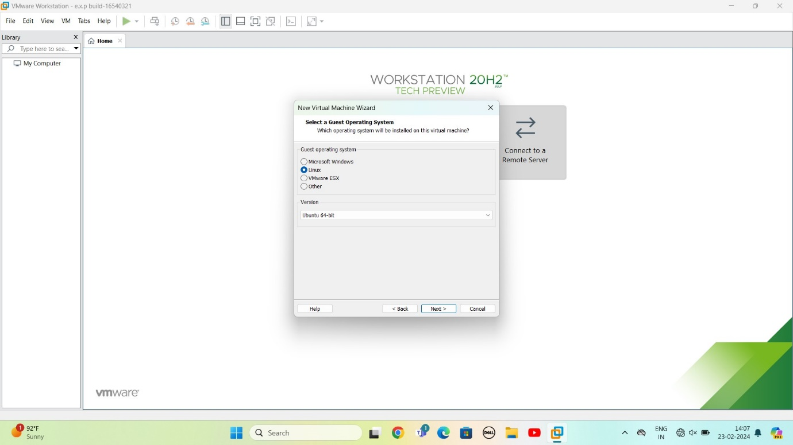

**STEP 5** selects name of virtual machine Give next

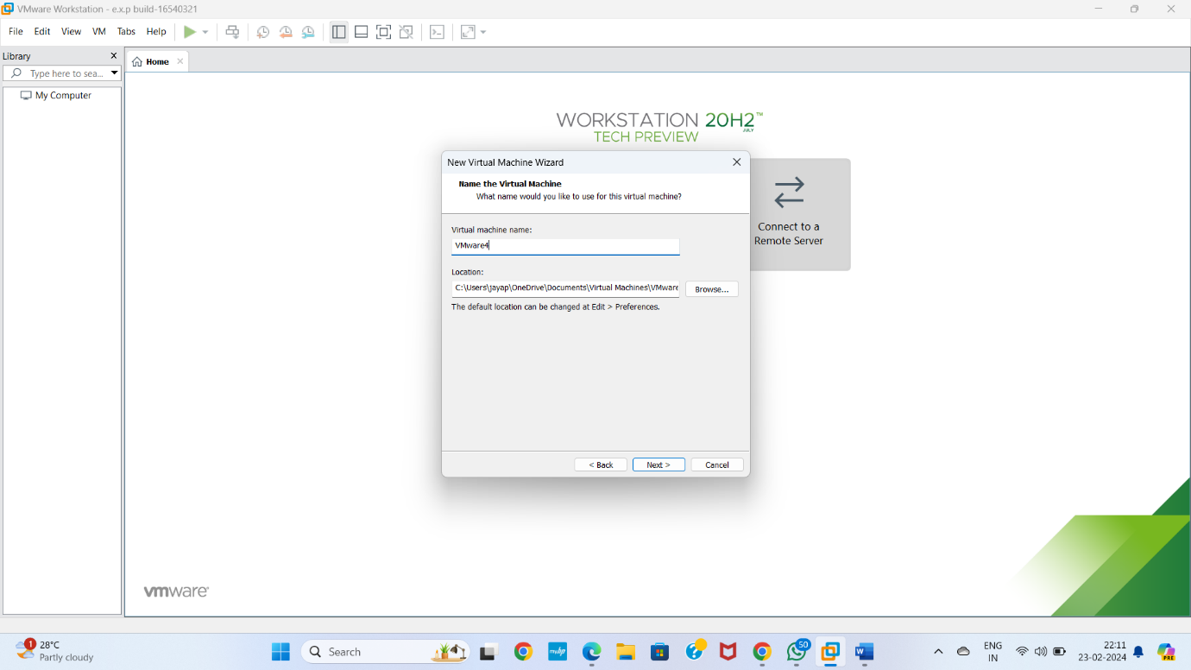

**STEP 6** selects the data storing disk and maximum size of disk

IN question they given maximum size=20.0 change value

Give next

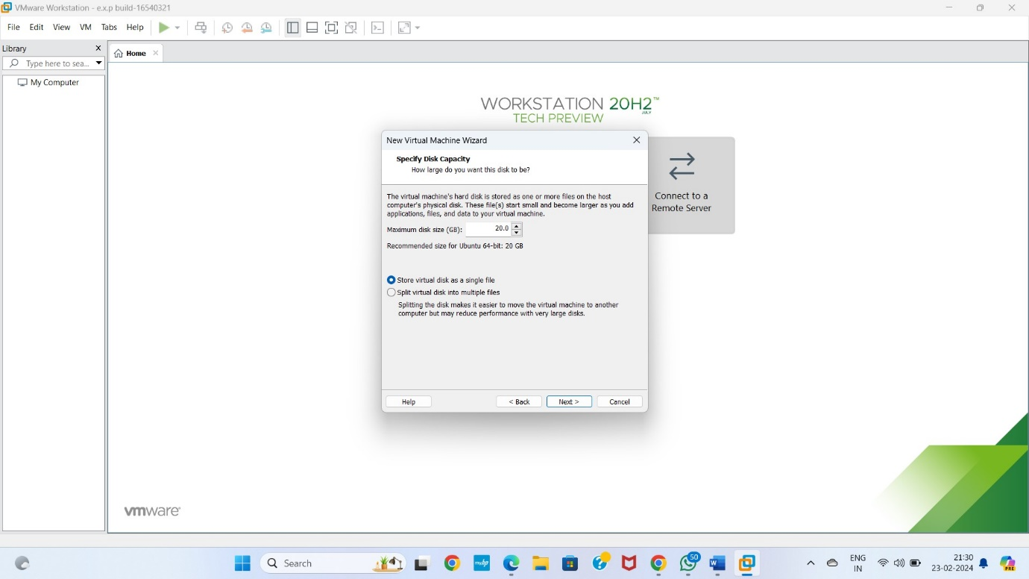

**STEP 7** Ready to create virtual machine

Give finish

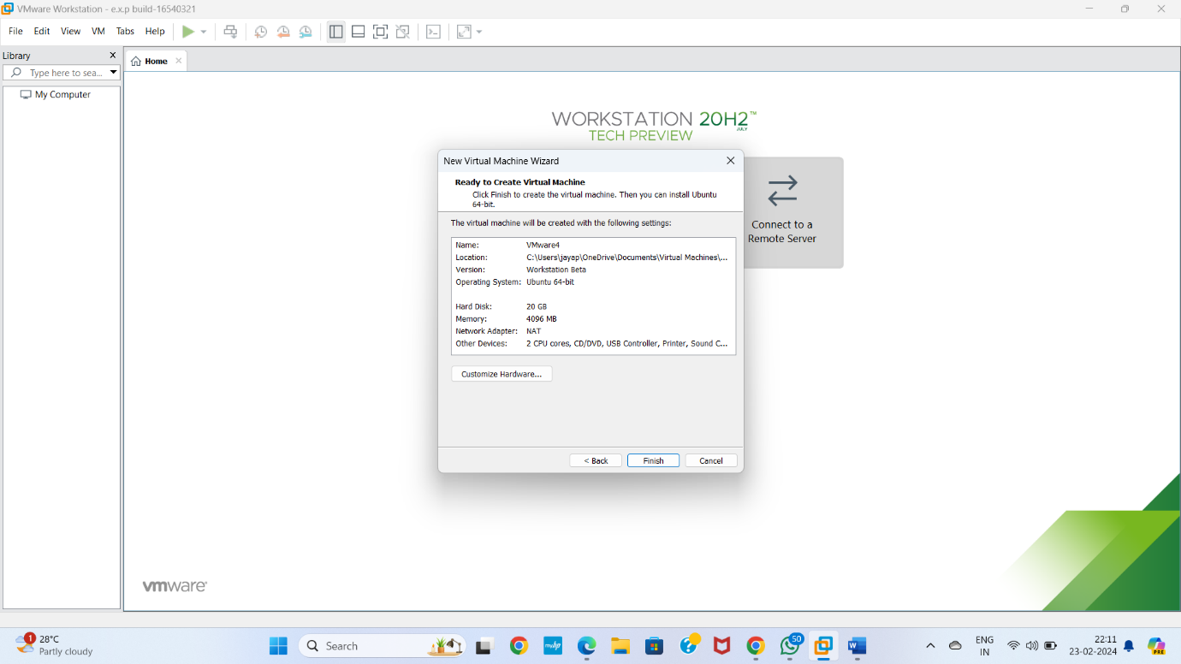

**STEP 8** Created the virtual machine

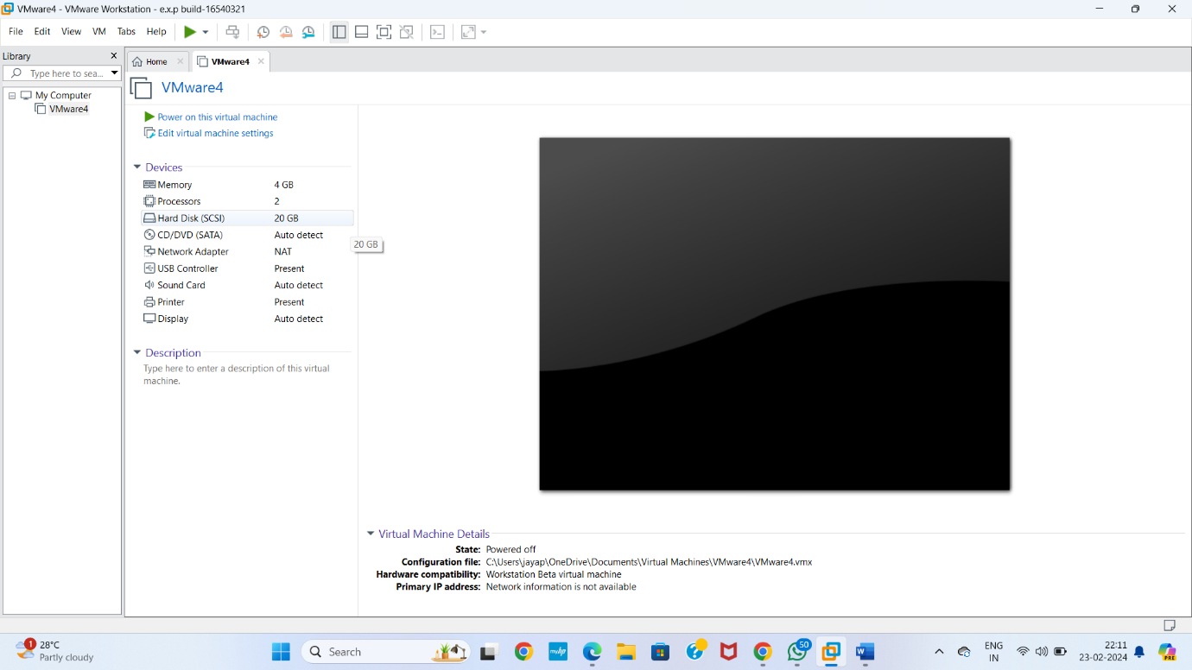

**STPE 9**CLONE THE CREATED SOFTWARE

GOTO VM SELECT OPTION MANAGE

IN THAT SELECT CLONE

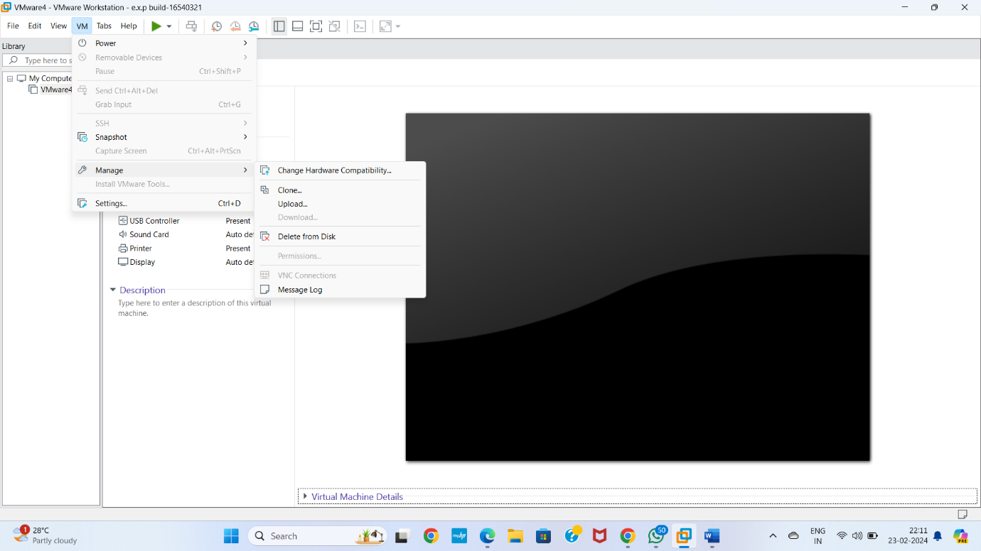

**STEP 10** Select clone from Give next

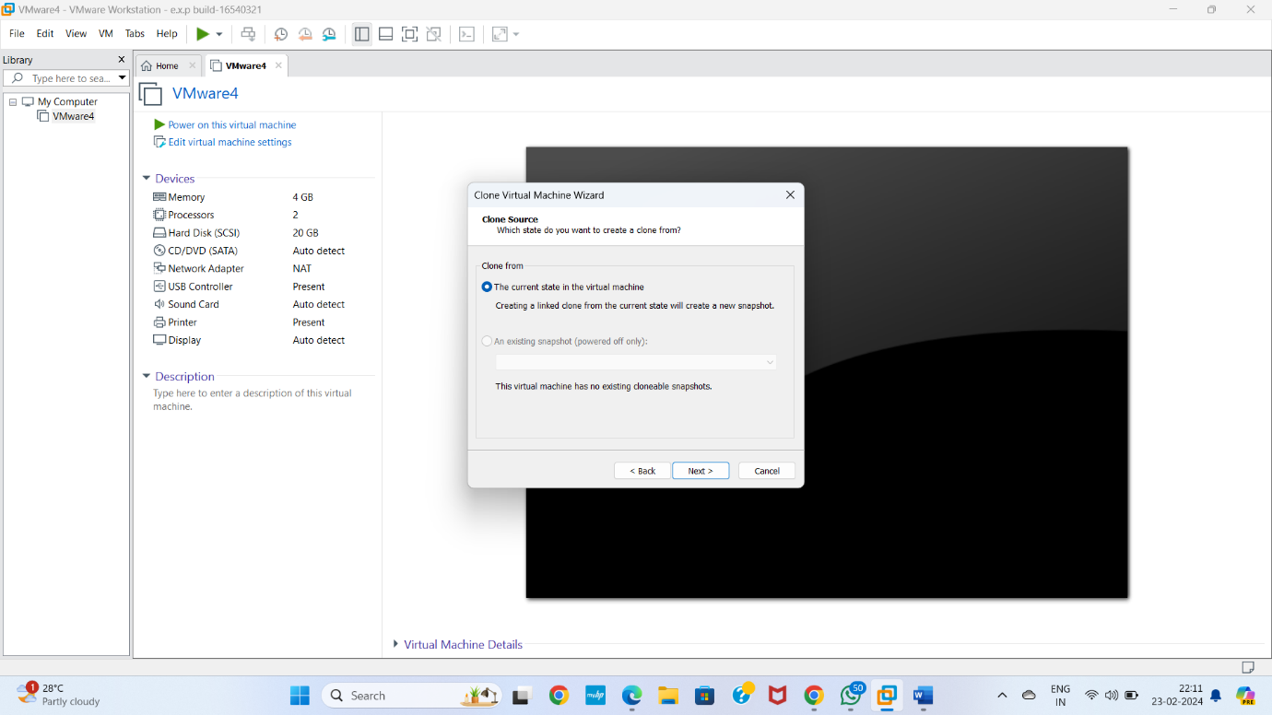

**STEP 11** Select clone type

Give next

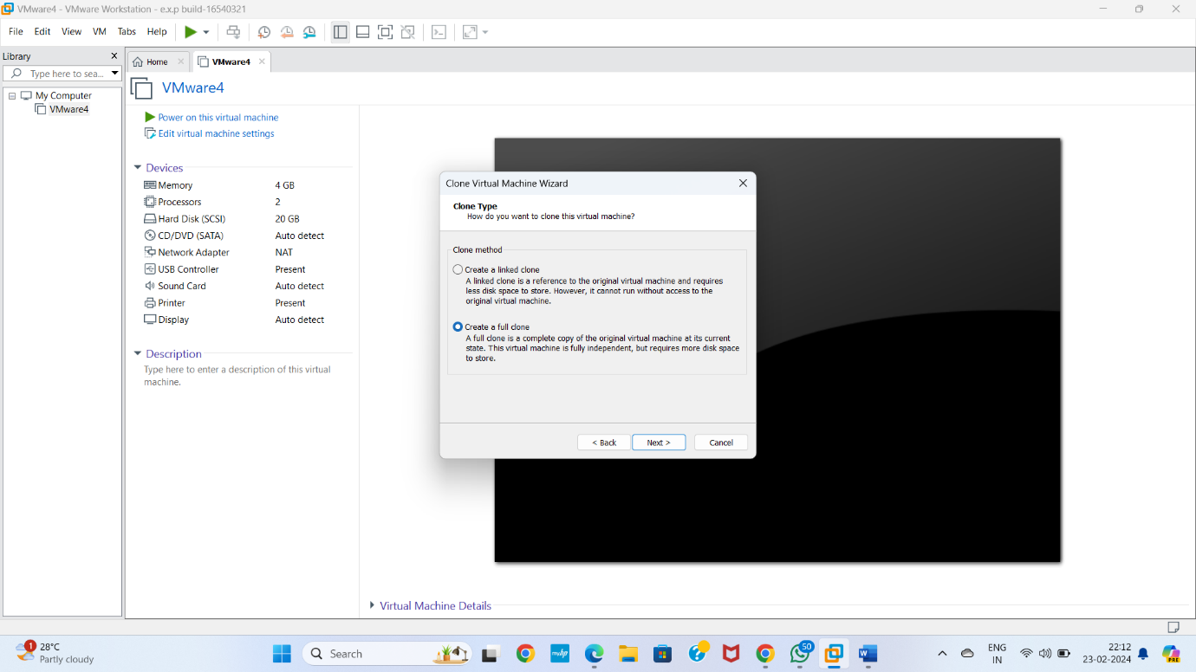

**STEP 12** SELECT NAME OF VIRTUAL MACHINE

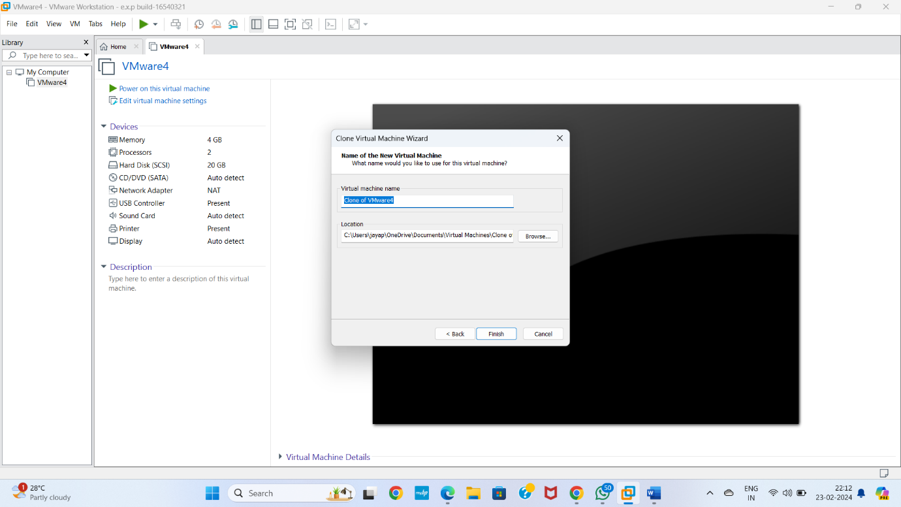

**STEP 13** Cloning virtual machine is ready

Give close

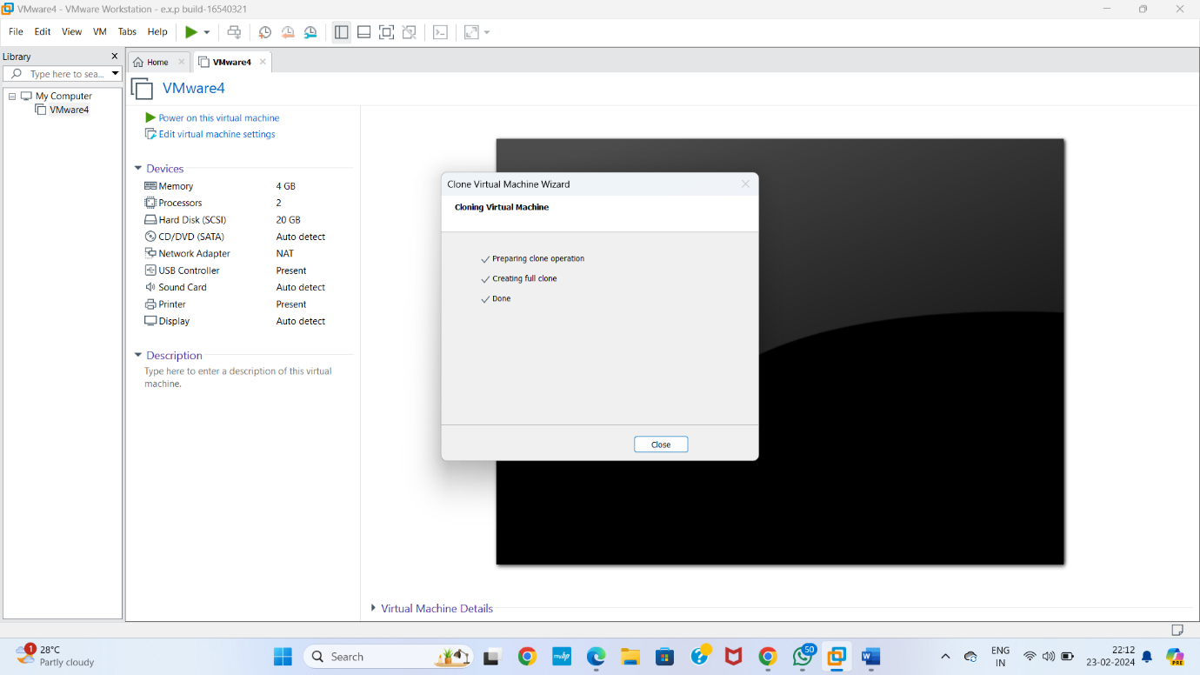

**STEP 14** cloning virtual machine is ready

